Annex I
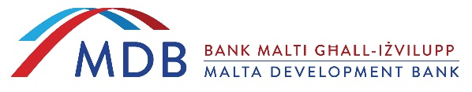

Anti-Fraud Declaration

I, the undersigned, hereby declare that in my official capacity to bind _________ [name of company] _____________ shall, upon award of this Request for Quotation in relation to the procurement of the Stainless Steel Recycling Bins, bind itself to undertake all of the following:
- not to commit any form of fraud;
- to take appropriate measures to deter fraud;
- to introduce and maintain necessary procedures to prevent, detect and deal with suspected fraudulent activity;
- to report to the Bank all suspected fraud concerning any arrangement entered into with the Bank;
- if required, to assist the Bank in the investigation of suspected fraudulent activity and in the recovery of wrongfully obtained assets concerning an arrangement entered into with the Bank; and
- to ensure employees of the company report any suspicion of fraud.

________________
Name:
Designation:
Name of Company:
Date:

MDB guarantees that any personal data processed within this form shall be in accordance with the requirements of local and EU legislation on data protection in force at the time of the data processing including the General Data Protection Regulation- (GDPR) (Regulation (EU) 2016/679. All the personal data collection in this form will be considered under the classification of ‘confidential’. Persons have the right to access and port their personal data, rectify, erase and restrict their personal data and to object to processing in terms of the GDPR.

