Supply and Installation of
Videoconference Systems

RFQ/2021/VcS01

12.11.21

Classification of Document Data: Restricted

Reference Number: RFQ/2021/VcS01

Background information
The Malta Development Bank (herein referred as “MDB” or the “Bank”) performs a promotional role in line with public policy with the objective to contribute towards sustainable economic development that benefits the Maltese people in areas including private sector development, skills and technology, infrastructure development, green economy and community services.

​The MDB is interested in setting up professional videoconferencing facilities in two rooms at its new premises in Floriana. The proposed videoconferencing system must meet the overall objectives outlined in Sections 2 and 3 of this document, and equipment must be compliant with the Technical Requirements listed in Section 4.

Objectives
This Request for Quotations (RFQ) is for the design, supply and implementation of two (2) videoconferencing systems at the MDB.

The MDB invites suppliers to propose a cost-effective solution for the provision and implementation of professional videoconferencing facilities in two rooms, namely, the Boardroom and the Conference Room. These rooms will host high-level meetings with senior management and therefore the solution proposed should offer a sleek, professional design for a wall-mounted display, soundbar and camera, for high standard videoconferencing facilities.

Moreover, the solution must allow MDB users to:
- participate in videoconferences using in-built applications offered natively by the equipment proposed;
- collaborate using Microsoft Office tools directly on the devices provided;
- connect external laptop(s) / device(s) to the equipment using wireless technology to project content onto the display.

The schematics below provide an illustration of the general layout of the two rooms where the videoconferencing systems shall be located and the desired positioning of the wall-mounted LCD display. The schematics are not to scale. Suppliers are invited to propose designs that would meet the MDB’s requirements for effective videoconferencing within these areas. Suppliers may propose a complete wall-mounted setup or, alternatively, a wireless approach to avoid cables cluttering the rooms concerned without detracting from overall quality of the solution.

Conference Room

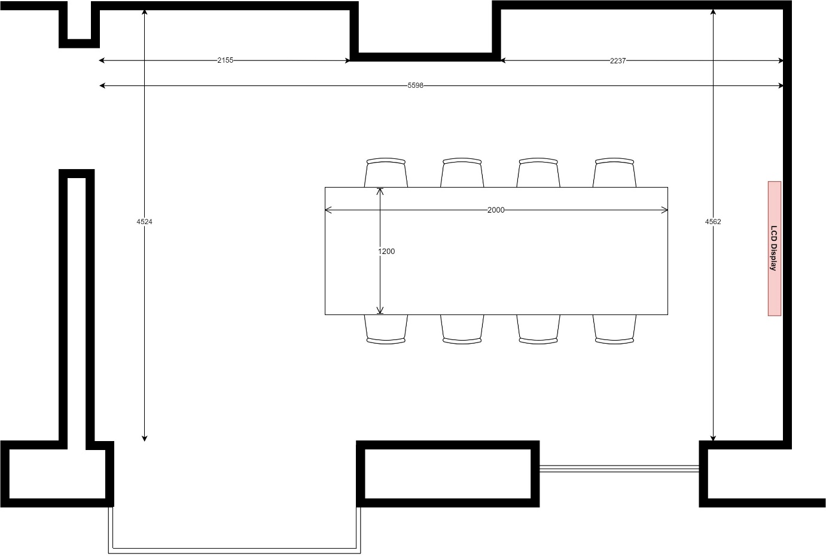

Boardroom

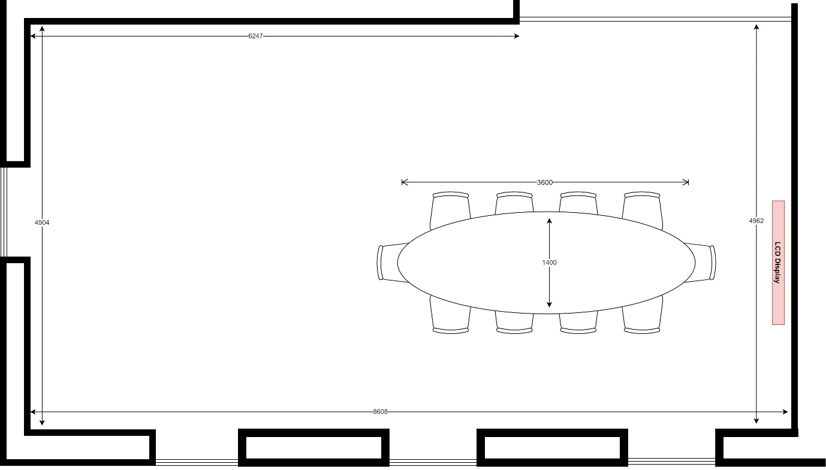

It is important for suppliers to set an appointment and visit the sites in order to accurately assess the physical spaces involved and the works required prior to submitting the quotation.

Proposal Requirements
The Proposal shall include:
- A completed Compliance to the Bank’s stipulated Technical Requirements, as per Section 4 of this RFQ.
- A completed Financial Bid as per Section 5, which should outline the total final price including all requirements to finish the task. No price variation shall be allowed for any rise or fall in the cost of labour, materials etc. for the duration of the works. Applicants should note that the MDB may publish the final award price of the appointed Applicant;
- An estimated timeline including start date and completion date. Applicants shall demonstrate their ability to commence the works at the earliest (specific date to be provided), providing details also of the team size and experience performing this task. Flexibility in managing deadlines is also important;
- The ESPD Form if already available or you may choose to submit the Bank’s Eligibility Declaration Form, both attached; and
- Any accompanying literature on the equipment being proposed, that may facilitate the evaluation process.

Bidders may be requested to submit (a) technical and professional abilities complete with the personnel details, and also (b) a reference list of projects of a similar nature to the one specified in this RFQ, previously undertaken or provided by them over the past five (5) years. As part of the Bank’s evaluation process, the bidders may be requested to provide a demo of the proposed setup.

Successful Bidders may also be requested to submit a certified Jobsplus list of personnel employed by them.

Technical Requirements

Requirements | Compliant  (Y/N) | Comments
Interactive LCD Display
Minimum 65” wall-mounted display
IPS panel technology
Minimum native resolution of 3,840 x 2,160
Minimum native contrast ratio of 1,300:1
Direct LED Backlight
Includes HDMI ports (specify number available)
Includes USB ports (specify number available)
Includes Ethernet (LAN) connection
Includes RS-232C connection
Includes an Optical Digital Audio Out
Internal speakers
Built-in Wireless LAN
Tempered glass
Anti-glare coating
Built-in wireless presentation capabilities
Operating system compatibility (Windows 10 / Android)
Physical dimensions (specify W x H x D)

Requirements | Compliant  (Y/N) | Comments
External Sound and Camera
Speakers
High‑powered stereo speakers
Built-in amplifier
Acoustic echo cancellation
Dynamic noise suppression
Includes USB connection for audio and video connectivity (specify number available)
Analog input to amplify external audio source
Plug & Play compatible with major computer OS platforms to run any web conferencing software
Microphone
Built-in microphone
Pickup range and angle to cover all the area and seated participants as outlined in room schematics – please specify
Camera
Ultra-wide angle
Pan / Tilt / Zoom capabilities
Field of view – please specify
Output full HD Resolution 1080p
Autozoom on speaker and participants
Automatic real-time scaling and perspective correction
Dynamic light optimisation
Miscellaneous
Minimum 3 years warranty on all equipment
Accompanying accessories (manuals, remote, power cords, wireless keyboard, wireless mouse, etc.) – please specify
Software licences required (if applicable) – please specify
Earliest delivery time of solution on confirmation of order – please specify
Onsite Implementation
Training to operate the solution to be included in the offer
On-going support on the solution (if applicable)
Would you be in a position to provide the Bank with a working demonstration of the proposed solution, as part of the evaluation process?

Financial Bid
The Supplier must provide a completed bill of quantities as per below:

Component | Qty | Unit Cost  (VAT included) | Total Cost  (VAT included)
Interactive LCD 65” Display | 2
Sound and Camera devices | 2
Implementation Services | 1
Software licences (where applicable) | 2
On-going support (where applicable) | 1
Total Solution Cost

Optional
Additional cost to upgrade the LCD 65” Display to a touchscreen model, including built-in annotation tools and necessary software components, whilst maintaining compliance with the technical requirements listed in this document | 1

Subcontracting
Subcontracting and awarding this RFQ in Lots may be accepted after seeking the Bank’s prior consent.

Award of successful quotation
The Bank shall award the Quotation on the basis of the most economically advantageous proposal in terms of the weightings indicated as per Section 8 on the Evaluation Award Criteria.

The Bank reserves the right to reject a proposal which appears to be priced abnormally low in relation to the services/goods to be provided. The Bank reserves the right to request further clarification, documentary evidence, explanation or elaboration in writing on any aspect of the application or declarations made.

The Bank may, in its absolute discretion:
- change, as deemed necessary in view of circumstances, the basis of, or the procedure of the RFQ process;
- reject any or all of the proposals if eligibility criteria are deemed not fully met to its satisfaction;
- do such things or engage in such actions as it deems necessary to ensure that the services and provision thereof yield value for money, which may include requiring a resubmission of any element of the proposal;
- furnish Applicants with additional information in respect to any aspect of the services;
- abandon the RFQ process upon immediate notification to Applicants;
- terminate the contract without prior notice if the Bank becomes or is made aware, after award of the Project, that an Applicant failed to comply with any of the requesting criteria. The MDB reserves the right to claim payment from the non-compliant Applicant of any damages, loss and expenses incurred as a result of the termination.
- draw the attention of successful applicants to the conditions concerning employment in Malta and the obligation to comply with all regulations, rules or instructions concerning the conditions of employment of any class of employee.

Evaluation Award Criteria
The following are the evaluation award criteria weightings that will be adopted by the selection panel when reviewing all proposals received:

Criteria | Weighting
Aesthetically pleasing and professional design | 10%
Compliance to technical requirements | 50%
Cost | 40%

GDPR and Freedom of Information Compliance
The MDB is subject to the provisions of the Freedom of Information Act as well as other legislation governing access to information. Therefore, where Applicants consider any information that they provide in the course of this RFQ process to be commercially sensitive or confidential in nature, they should identify that information as “commercially sensitive” or “confidential” and specify the applicable reasons. The nature of the documentation may then be taken into account by the MDB in considering requests (if any) for access to such information under the Freedom of Information Act or other applicable law. Applicants should note that on conclusion of a contract for the services that are the subject-matter of this competition, a right of access to the contract and associated documents will be available to the extent required by the Freedom of Information Act 2014 or other applicable law.

The submission of any personal data (including any personal data contained in any curriculum vitae) (“Personal Data”) shall be provided by the Applicant for the use by the MDB of that Personal Data for the purpose of evaluating the proposals and in performance of arising contractual obligations. Once it obtains any Personal Data, the MDB will act as data controller of such data and will retain it for (a) in respect of an unsuccessful applicant, up to one year following completion of the appointment of the successful applicant and (b) in respect of a successful applicant, up to seven years following completion of the Services. An Applicant may exercise his/her rights in connection with the processing of his/her personal information by MDB by contacting the DPO by email at dpo@mdb.org.mt. For further information in relation to how the MDB processes personal data, including an individual’s various rights under data protection law and details of how to contact the MDB, please refer to the MDB’s Privacy Notice which is available at: https://mdb.org.mt/en/home/Pages/Privacy-Notice.aspx
Should you have any questions, kindly revert by email on procurementproposals@mdb.org.mt.

The MDB may, notwithstanding any provision to the contrary in this RFQ, publicise or otherwise disclose, to any third party, information regarding the contract, the identity of Applicants (including details of their respective members), the RFQ process, or the award of Services (including, without limitation, details of costs and fees) at any time.

Submission of Proposals

All the documentation shall be submitted by Monday 6 December 2021 at 18:00 CET on procurementproposals@mdb.org.mt. Late submissions will not be accepted. Evaluation of the quotations received will only take place after the 6 December at 18:00 CET.

At any time during the RFQ process, in case of the need for any clarifications with regard to the specifications required or should you have any questions, kindly revert by email on procurementproposals@mdb.org.mt. The final date for seeking clarifications will be Wednesday 1 December 2021 at 18:00 CET.

The Bank reserves the right to extend the closing date and to cancel the request for quotation and evaluation process at any stage. The Bank shall inform all the prospective applicants without being liable for any costs and damages including, without limitation, damages for any loss of profits, in any way connected with the cancellation of the request for quotations.

Please quote the reference number of this Request for Quotation in your correspondence. All submissions will be dealt with in strictest confidence.

